Unveiling Market Insights: Analyzing Spending Behaviour And Identifying Opportunities For Growth

1.INTRODUCTION

1.1.overview

In today's highly competitive business landscape, understanding consumer spending behavior is essential for sustainable growth and market source. "Unveiling Market Insights'' is a strategic initiative focused on comprehensively analyzing spending patterns and harnessing this knowledge to uncover opportunities for business expansion and optimization. This seeks to provide a holistic overview of how consumer spending impacts your organization and the strategies required to capitalize on these insights.

1.2.purpose

1. Understand Consumer Behavior: The primary purpose is to gain a deep understanding of how consumers allocate their resources, make purchasing decisions, and interact with your products or services. This understanding helps in building a more customer-centric approach.
2. Identify Growth Opportunities: By analyzing spending behavior, the project aims to uncover specific growth opportunities within the market. This could include identifying underserved customer segments, unmet needs, or areas where your business can expand its offerings.
3. Optimize Marketing Strategies: The insights derived from spending behavior analysis can inform the development and refinement of marketing strategies. Businesses can tailor their messaging, advertising channels, and promotions to better resonate with their target audience.
4. Enhance Product/Service Offerings: Understanding what customers value and how they spend can guide product or service improvements. It helps in refining existing offerings and developing new ones that align with customer preferences.
5. Maximize Revenue: The ultimate purpose is to drive revenue growth. By leveraging insights into spending behavior, businesses can increase sales, boost profitability, and enhance overall financial performance.
6. Competitive Advantage: This project can provide a competitive edge by enabling the organization to stay ahead of market trends and respond effectively to changing consumer preferences.
7. Adaptability and Resilience: Equip the organization with the ability to adapt to evolving market conditions and economic uncertainties by having a better understanding of consumer behavior and market dynamics.
8. Long-Term Sustainability: By identifying and capitalizing on growth opportunities, the project contributes to the long-term sustainability of the organization, ensuring its continued relevance and success in the market.

2.PROBLEM DEFINITION & DESIGN THINKING

2.1.Empathy Map

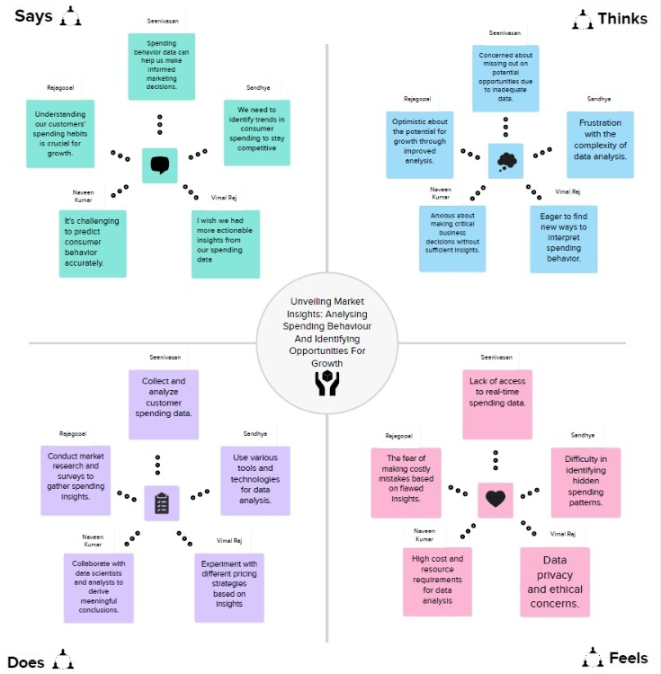

2.2 Ideation & Brainstorming Map

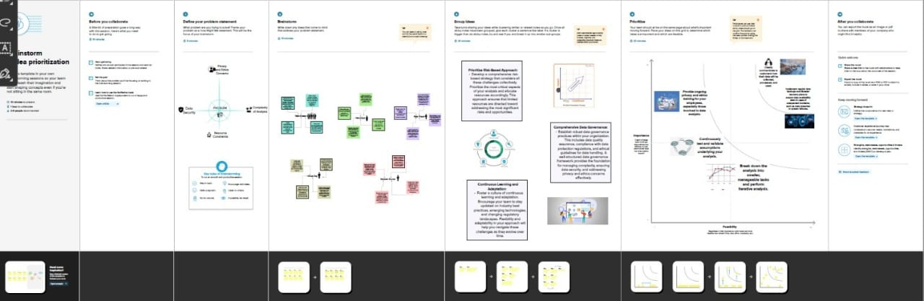

3.RESULT

This project is designed to provide businesses with valuable insights into consumer behavior, enabling them to make informed decisions that drive revenue growth and ensure long-term competitiveness in the market. It emphasizes the importance of data-driven decision-making and a customer-centric approach to business strategy .the organization can use insights to enhance the overall customer experience, making interactions more personalized and satisfying. As a result of successful growth strategies, the organization can strengthen its position in the market and potentially gain market share.

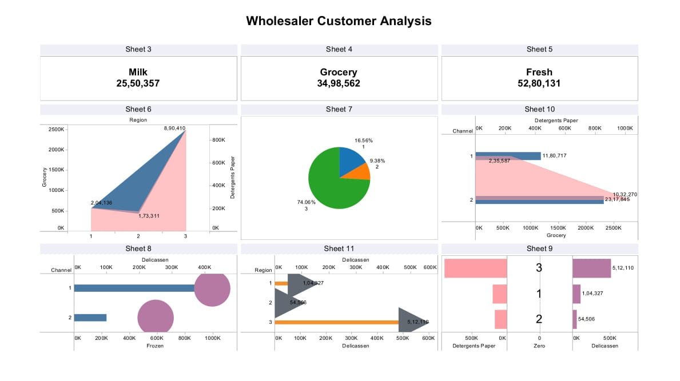

4.ADVANTAGES & DISADVANTAGES

4.1.Advantages:

1. Improved Customer Understanding: Deeper insights into spending behavior provide a better understanding of customer preferences, needs, and pain points, allowing for more targeted and customer-centric approaches.
2. Competitive Advantage: Identifying growth opportunities and responding to market trends ahead of competitors can give organizations a significant competitive advantage, helping them stay ahead in the market.
3. Revenue Growth: The project aims to identify revenue-generating opportunities, ultimately leading to increased sales and profitability.
4. Customer Retention: Strategies developed through spending behavior analysis can help improve customer retention rates, reducing customer churn and the cost of acquiring new customers.
5. Risk Mitigation: Understanding spending behavior allows organizations to anticipate market shifts and economic uncertainties, making them more resilient to unexpected challenges.
6. Long-Term Sustainability: By identifying and capitalizing on growth opportunities, organizations can ensure their long-term sustainability and relevance in their respective industries.

4.2.Disadvantages:

1. Data Complexity: Analyzing spending behavior data can be complex and time-consuming, particularly if the data is large-scale, unstructured, or comes from various sources. Handling and processing this data may require significant resources and expertise.
2. Data Privacy and Security: Collecting and analyzing customer spending data can raise privacy and security concerns. Organizations must adhere to data protection regulations and implement robust security measures to safeguard sensitive information.
3. Costs: Conducting comprehensive market research, customer surveys, and data analysis can be expensive. Smaller organizations may find it challenging to allocate the necessary budget and resources.
4. Time-Consuming: Data analysis and deriving actionable insights can be time-consuming. Organizations may need to invest a considerable amount of time before seeing tangible results.
5. Dependency on Data Quality: The quality and accuracy of the data used for analysis are critical. Inaccurate or incomplete data can lead to incorrect conclusions and ineffective strategies.

5.APPLICATION

* Retail Industry
* Hospitality and Tourism
* Technology and Software
* Manufacturing and Supply Chain
* Food and Beverage Industry

6.CONCLUSION

In a rapidly evolving business environment, gaining insights into spending behavior and identifying growth opportunities are crucial for staying competitive and relevant. "Unveiling Market Insights" represents a strategic initiative that empowers organizations to navigate market dynamics, meet customer expectations, and achieve sustainable growth. It underscores the value of data as a strategic asset and the importance of staying customer-centric in a dynamic and competitive marketplace.

7.FUTURE SCOPE

1. Advanced Data Analytics: As data analytics tools and techniques continue to advance, the project can benefit from more sophisticated data analysis methods, including machine learning and artificial intelligence. Predictive analytics can be used to forecast future spending behaviors and trends with greater accuracy.
2. Real-Time Data: The future of this project involves real-time data analysis, enabling organizations to respond rapidly to changing consumer behaviors and market conditions. This real-time insight can inform dynamic pricing strategies and immediate marketing adjustments.
3. Sustainable Consumer Behavior: Future scope can encompass the analysis of spending behavior related to sustainability and ethical consumption, helping organizations cater to environmentally conscious consumers.
4. Behavioral Economics Integration: The project can incorporate principles from behavioral economics to understand consumer biases and decision-making processes better, enabling organizations to design strategies that align with cognitive tendencies.

Links:

Dashboard Public Link - <https://public.tableau.com/app/profile/seenivasan.k7534/viz/WholesalerCustomerAnalysis_16964283786400/Dashboard1?publish=yes>

Story Public Link - <https://public.tableau.com/app/profile/seenivasan.k7534/viz/WholesalerCustomerAnalysisstory_16966013254610/Story1?publish=yes>

Video Demonstation Link - <https://drive.google.com/file/d/1RQ_i2HHmxw9wdRtgyiBJiBGS6l-FhguC/view?usp=drivesdk>